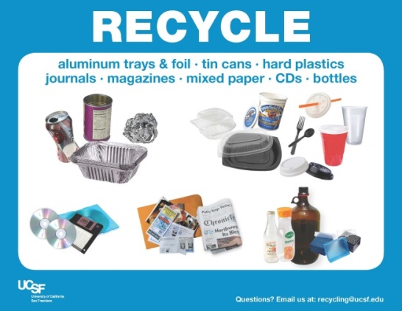**UCSF Recycling & Waste Reduction**

**Mission:**   
To incorporate best practices in recycling, composting, and re-use at UCSF facilities, diverting and reducing the total amount of waste sent to the landfill each year.

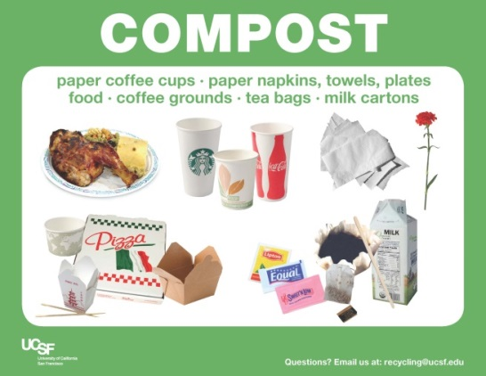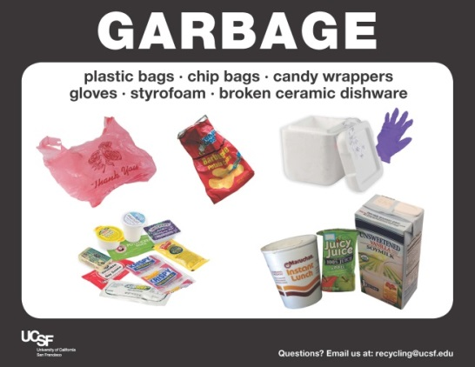**Goal:**   
Zero waste by 2020. Meaning everything that can be recycled, composted or reused, is correctly discarded.

**Services:**

Free signage

Free compost and recycle containers

Free education and training   
School, office and art supply donation pick up

Scrap metal collection

Office & Lab clean out assessment

Zero Waste Event Planning

**Mission Hall:**

*Desk side* – Recycling and garbage containers are provided at your desk. You are responsible for servicing these bins so please dispose of compost at the Kitchen town centers.

*Kitchen Town Centers* - Recycling, compost and garbage containers are clearly labeled throughout the kitchen areas. Please do your best to sort your waste correctly; feel free to contact us with questions.

*Common areas* – Recycling and garbage containers will be located throughout the neighborhood office areas for disposal access. You will find all three recycling, compost and garbage containers on the first floor lobby and throughout the conference center.

*Restrooms* – All restrooms have containers for paper towel compost. Small garbage pales are also available.

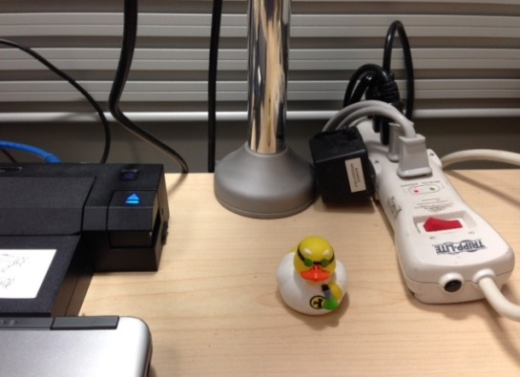**UCSF Sustainability:**

*Workstation power -* Put all workstation equipment: screen, computer, phone, task lighting, and other appliances on a power strip on your desk and turn off at the end of the day. This will save over 50% of the energy use of your workstation.

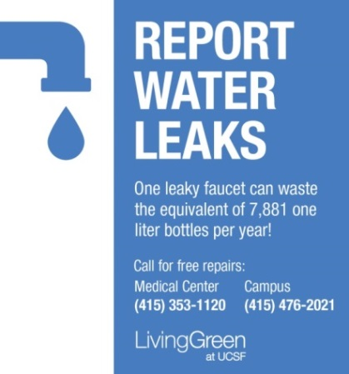This logo on your bottom task bar indicates you have an automatic sleep software loaded. If you don’t see this, you can upload it. Click [HERE](http://software.ucsf.edu/protected/bigfix/UCSF-BigFix-Gen-OSX.dmg) for a MAC or [HERE](http://software.ucsf.edu/protected/bigfix/UCSF-BigFix-Gen-Win.exe) on a PC. Or go to livinggreen.ucsf.edu/1.267

Report water leaks or water waste wherever you see it. Work orders are accepted free of charge by calling the numbers above.